HST 487 | Spring 2017 | M 7:10-10pm | 115 Berkey | Prof. Peter Alegi
GLOBAL SOCCER:
SOCIAL AND CULTURAL HISTORY

Using a variety of archival, media, oral, and audio-visual sources, we will grapple with questions: How did the modern game develop, on the pitch and in the boardroom? Was soccer a tool for Western imperialism or a vehicle for indigenous resistance? How have national, racial, ethnic, gender, class, and community identities been expressed through the game? How and why has soccer functioned as a force for empowerment and disempowerment? How has global capitalism changed the modern game? The main goals of this course are to gain specialized knowledge of soccer’s social and cultural history and to strengthen skills in critical reading, analytical writing, and oral communication.
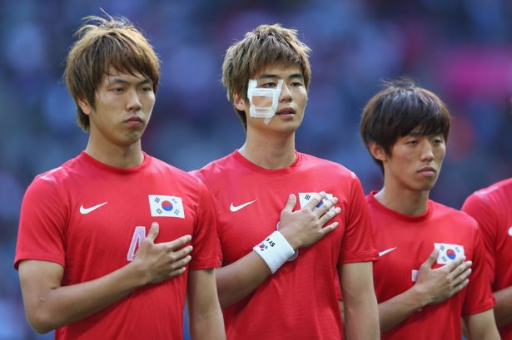

Soccer (football) is probably the most popular form of mass culture in the world. This course goes beyond highlights, “barstool talk,” and FIFA videogames to explore the history of soccer and social change in a global context.

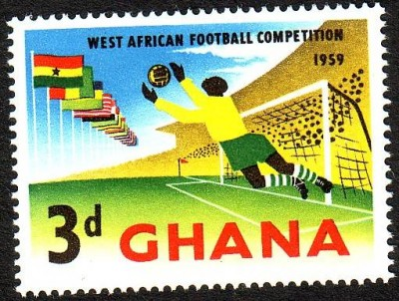

The aim of the course is to deepen knowledge and understanding of soccer’s broader implications and to consider the complex interactions of local and international dynamics in shaping the global past. Since it is impossible to adequately cover the globe in just one semester, the course combines general themes and trends with in-depth case studies from different world regions.

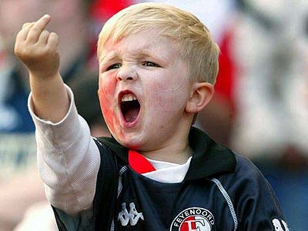

Required Books

- Peter Alegi, Laduma! Soccer, Politics, and Society in South Africa (2010 edition)
- Laurent Dubois, Soccer Empire: The World Cup and the Future of France
- Robert Edelman, Spartak Moscow: A History of The People’s Team in the Workers’ State
- Brenda Elsey, Citizens and Sportsmen: Fútbol and Politics in Twentieth-Century Chile
- David Goldblatt, The Game of Our Lives: The English Premier League and the Making of Modern Britain
- Barbara Jacobs, The Dick Kerr’s Ladies: The Factory Girls Who Took On the World
- Roger Kittleson, The Country of Football: Soccer and the Making of Modern Brazil
- Sid Lowe, Fear and Loathing in La Liga: Barcelona vs Real Madrid

Note: Readings in the syllabus with an asterisk are for graduate students only.

Attendance & Participation
Attendance is required. Students who miss more than one class meeting will fail the course. Meticulous preparation, on-time arrival, and active participation in class are crucial components of the seminar.

Weekly Précis

Each week students write a 2-page (double-spaced) summary of the assigned book. These papers must concisely describe the book’s organization, content, sources, argument(s), and main findings.

Analytical Papers

Each week one or more members of the seminar will write an analytical paper 8-10 pages in length (3000 words max.) on the assigned reading. No précis are required when writing the longer paper. Three such papers are required during the semester. As critical reviews (not summaries), these papers will (a) evaluate the strengths and weaknesses of the assigned material—including sources and methodology, structure and argument, and significant contributions—and (b) raise questions and thought-provoking points to frame, stimulate, and sustain class discussions. Authors will upload papers in Word or PDF format to the course’s D2L site by Sunday at 8pm. In addition, authors will make a short presentation at the beginning of class to introduce their paper and provide additional context. No late papers will be accepted, except in case of a documented medical emergency.

Course Assessment

Grading will be based on this standard: Attendance & participation = 15%; Précis work = 25%; Analytical Papers = 60% (20% each)

Grading Scale: 4 (92-100) = outstanding; 3.5 (91-85)= very good; 3 (84-80)= satisfactory; 2.5 (79-75) = fair; below 2.5 = poor

Office Hours
I am available on Tuesdays and Wednesdays, 10-11:30am, and by appointment, in 160A Old Hort. I can be reached by phone (517-884-4877) and by e-mail (alegi@msu.edu). Follow me on Twitter @futbolprof

COURSE SCHEDULE

1/9: INTRODUCTION

FILM SCREENING: More Than Just A Game

[1/16: NO CLASS. Martin Luther King Jr. Holiday. Start reading for 1/23.]

1/23: THE WORLDS THAT SOCCER MADE

Read
- David Goldblatt, The Ball is Round: A Global History of Soccer, 3-49
- Jean Williams, A Beautiful Game: International Perspectives on Women’s Football, 1-31
- Matthew Taylor, “Global Players? Football, Migration and Globalization, c. 1930-2000,” Historical Social Research 31, 1 (2006): 7-30
- Christian Bromberger, “Football as World-view and as Ritual,” French Cultural Studies 6 (1995): 293-311
- *Richard Giulianotti and Roland Robertson, “Recovering the Social: Globalization, Football and Transnationalism,” Global Networks 7, 2 (2007): 144–186
- *Clifford Geertz, “Deep Play: Notes on the Balinese Cockfight,” Daedalus 101, 1 (Winter, 1972): 1-37
- *Robert Gordon and Marizanne Grundlingh, “Going For the Reds: Max Gluckman and the Anthropology of Football” in A. Schwell et al., eds., New Ethnographies of Football in Europe, 21-36

1/30: FUTEBOL AND THE MAKING OF MODERN BRAZIL

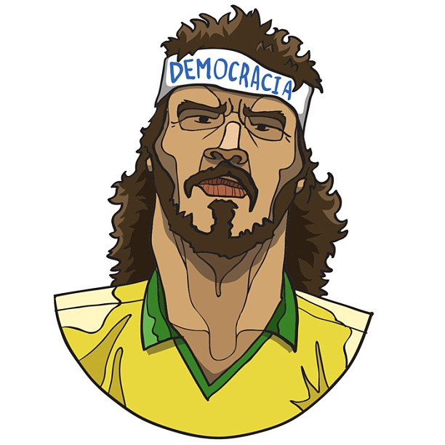
Read
- Roger Kittleson, The Country of Football: Soccer and the Making of Modern Brazil

Recommended
- Joshua Nadel, Fútbol! Why Football Matters in Latin America
- Janet Lever, Soccer Madness: Brazil’s Passion for the World’s Most Popular Sport
- Alex Bellos, Futebol: The Brazilian Way of Life
- Ruy Castro, Garrincha
- Tony Mason, Passion of the People? Football in South America
- Ben McGrath, “Samba Soccer: The Transformation of Brazil’s Most Storied Team,” The New Yorker, January 13, 2014
- Jose Sergio Leite Lopes, “The Brazilian Style of Football and its Dilemmas,” in G. Armstrong and R. Giulianotti, eds., Football Cultures and Identities, 86-95

2/6: FÚTBOL AND POLITICS IN CHILE
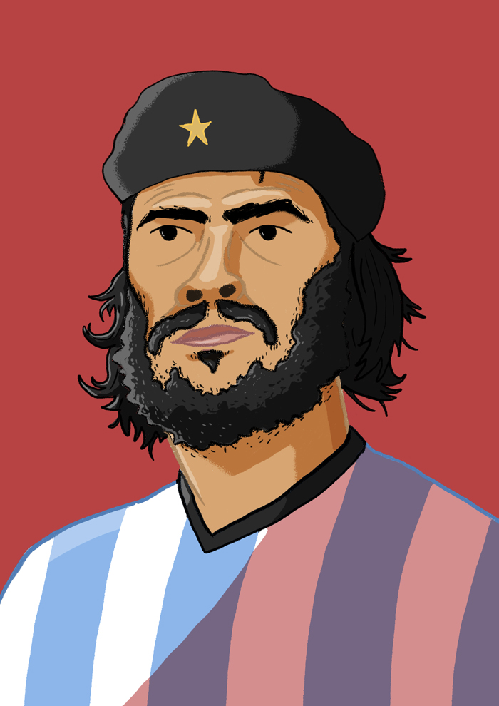

Read/Watch
- Brenda Elsey, Citizens and Sportsmen: Fútbol and Politics in Twentieth-Century Chile
- FILM: Ciudad Deportiva [link]

Recommended
- Roger Magazine, Golden and Blue In My Heart: Masculinity, Youth, and Power among Soccer Fans in Mexico City
- Vic Duke and Liz Crolley, “Fútbol, Politicians and the People: Populism and Politics in Argentina,” International Journal of the History of Sport 18, 3 (2001): 93-116
- Steve Stein, “The Case of Soccer in Early Twentieth-century Lima,” in J. L. Arbena and D. G. LaFrance, eds. Sport in Latin America and the Caribbean
- Gideon Rachman, “Beautiful Game, Lousy Business: The Problems of Latin American Football,” in R. M. Miller and L. Crolley, eds., Football in the Americas: Fútbol, Futebol, Soccer, 161-173

2/13: FOOTBALL AND APARTHEID IN SOUTH AFRICA

Read
- Peter Alegi, Laduma! Soccer, Politics, and Society in South Africa

Recommended
- Peter Alegi, African Soccerscapes: How a Continent Changed the World’s Game
- Peter Alegi and Chris Bolsmann, eds., Africa’s World Cup
- Gerard Akindes and Chuka Onwumechili, eds., Identity and Nation in African Football
- Gary Armstrong and Richard Giulianotti and, eds., Football in Africa
- Charles Korr and Marvin Close, More Than Just a Game: Football v Apartheid
- Chris Bolsmann, “The 1899 Orange Free State Football Team Tour of Europe: ‘Race’, Imperial Loyalty and Sporting Contest,” International Journal of the History of Sport 28, 1 (2011): 81-97
- Cynthia Fabrizio Pelak, “Women and Gender in South African Soccer: A Brief History,” Soccer & Society 11, 1 (2010): 63-78
- Hikabwa D. Chipande, “Mining for Goals: Football and Social Change on the Zambian Copperbelt, 1940s–1960s,” Radical History Review 125 (2016): 55-73
- Paul Darby, “‘Let Us Rally Around The Flag’: Football, Nation-Building, and Pan-Africanism in Kwame Nkrumah's Ghana,” Journal of African History 54 (2013): 221-246
- Tadasu Tsuruta, “Simba or Yanga? Football and Urbanization in Dar es Salaam,” in J. Brennan et al., eds., Dar es Salaam: Histories from an Emerging Metropolis (2007), 198-212

2/20: FRANCE’S SOCCER EMPIRE

Read
- Laurent Dubois, Soccer Empire: The World Cup and the Future of France

Recommended
- Geoff Hare, Football in France: A Cultural History
- Lindsay Krasnoff, The Making of Les Bleus: Sport in France, 1958-2010
- Hugh Dauncey and Geoff Hare, eds., France and the 1998 World Cup: the National Impact of a World Sporting Event
- Joan Tumblety, “The Soccer World Cup of 1938: Politics, Spectacles, and la Culture Physique in Interwar France,” French Historical Studies 1, 1 (2008): 78-116
- Philip Dine, “France, Algeria, and Sport: From Colonisation to Globalisation,” Modern & Contemporary France 10, 4 (2002): 495-505
- Pierre Lanfranchi and Alfred Wahl, “The Immigrant as Hero: Kopa, Mekloufi and French Football,” in R. Holt, J. A. Mangan, and P. Lanfranchi, European Heroes: Myth, Identity, Sport, 114-127
- L. Prudhomme-Poncet, “Les Femme, Balle Au Pied—A History of French Women’s Football,” in J. Magee et al, eds., Women, Football, Europe, 27-40

2/27: FOOTBALL, WOMEN, GENDER, & SEXUALITY

Read
- Barbara Jacobs, The Dick Kerr’s Ladies: The Factory Girls Who Took On the World

Recommended
- Jean Williams, A Beautiful Game: International Perspectives on Women’s Football
- Jean Williams, Globalising Women’s Football: Europe, Migration and Professionalization
- Fan Hong, J.A. Mangan, eds., Soccer, Women, Sexual Liberation
- Susan Cahn, “Sports Talk: Oral History and Its Uses, Problems, and Possibilities for Sport History,” Journal of American History 81, 2 (1994): 594-609
- Jeré Longman, The Girls of Summer: The U.S. Women's Soccer Team and How It Changed the World
- Brian Oliver, “All is not as rosy as it seems in the world of women’s football ahead of World Cup,” Inside The Games (June 7, 2015)
- Prishani Naidoo and Zanele Muholi, “Women’s Bodies and the World of Football in South Africa,” in A. Desai, ed., The Race to Transform: Sport in Post-Apartheid South Africa, 105-145
- Robbie Rogers, with Eric Marcus, Coming Out to Play
- Julie Foudy, “On Equal Pay, U.S. Soccer Has a Chance to Right FIFA’s Wrongs,” espnW.com (April 26, 2016)

3/6: SPRING BREAK!

3/13: FILM AND HISTORY, HISTORY AND FILM

- FILM SCREENING: Football Rebels. Discussion to follow.

Read
- Astrid Haas, “A Changing Game: Ethnicity, Gender, and Nation in the U.S. American Soccer Film,” Comparative American Studies 12, 4 (2014): 301-315
- Alon Raab, “Walls and goals: the Israeli–Palestinian Encounter in Football Films and Literature,” Soccer & Society 13 5-6 (2012): 789-794
- Luke Healey, “‘Hours and Hours of Mundane Moments and Then You Get This’: Motion and Punctuality in the Soccer GIF,” in D. Haxall, ed., Picturing the Beautiful Game: Essays on Soccer and Visual Culture [forthcoming]
- *Gavin M. Hicks, “Utopia of the Women’s Game—The Case of Football Undercover, in “Soccer and Social Identity in Contemporary German Film and Media,” (PhD dissertation, 2014): 77-123

Recommended
- Robert A. Rosenstone, Visions of the Past: The Challenge of Film to Our Idea of History
- Seán Crosson, Sport and Film

3/20: THE ENGLISH PREMIER LEAGUE & THE MAKING OF MODERN BRITAIN
Read
- David Goldblatt, The Game of Our Lives: The English Premier League and the Making of Modern Britain

Recommended
- Tony Mason, Association Football and English Society, 1863-1915
- James Walvin, The People’s Game: The History of Football Revisited
- Matthew Taylor, The Association Game: A History of British Football
- Charles P. Korr, “West Ham United Football Club and the Beginnings of Professional Football in East London, 1895-1914,” Journal of Contemporary History 13, 2 (1978): 211-232
- Rogan Taylor and Andrew Ward, “Kicking and Screaming: Broadcasting Football Oral Histories,” Oral History 25, 1, (1997): 57-62
- Stacey Pope, “Female Fan Experiences and Interpretations of the 1958 Munich Air Disaster, the 1966 World Cup Finals and the Rise of Footballers as Sexualised National Celebrities,” International Review for the Sociology of Sport (2014) DOI: 1012690214558284
- Phil Scraton, “Death on the Terraces: The Contexts and Injustices of the 1989 Hillsborough Disaster,” Soccer & Society 5, 2 (2004): 183-200
- David Conn, “Hillsborough disaster: deadly mistakes and lies that lasted decades,” The Guardian, April 26, 2016 [link]

3/27: FOOTBALL, STATE AND SOCIETY IN THE USSR

Read
- Robert Edelman, Spartak Moscow: A History of The People’s Team in the Workers’ State

Recommended
- Gabriel Kuhn, Soccer vs the State
- Vic Duke and Liz Crolley, Football, Nationality and the State
- Ben Carrington and Ian McDonald, eds., Marxism, Cultural Studies and Sport
- John Hoberman, Sport and Political Ideology
- Christian Koller and Fabian Brandle, Goal! A Cultural and Social History of Modern Football
- Alan Tomlinson and Christopher Young, eds., German Football: History, Culture, Society and the World Cup
- Arnd Kruger, “Strength, through Joy: The Culture of Consent under Fascism, Nazism and Francoism,” in A. Kruger and J. Riordan, eds., The International Politics of Sport in the Twentieth Century, 67-89
- Alan McDougall, “Whose Game Is It Anyway? A People’s History of East German Football,” Radical History Review 125 (2016): 35-54

4/3: MIDDLE EAST, PERSIAN GULF, AND EAST ASIA

Read
- Tamir Sorek, “Palestinian Nationalism Has Left The Field: A Shortened History of Arab Soccer in Israel,” International Journal of Middle East Studies 35 (2003), 417-437
- Kendra Stewart, “A Hobby or Hobbling? Playing Palestinian Women’s Soccer in Israel,” Soccer & Society 13, 5–6 (2012): 739-762
- Houchang Chehabi, “A Political History of Football in Iran,” Iranian Studies 35, 4 (2002): 371-402
- Wolfram Manzenreiter and John Horne, “Playing the Post-Fordist Game in/to the Far East: The Footballisation of China, Japan and South Korea,” Soccer & Society 8, 4 (2007): 561-577
- *Paul Michael Brannagan and Richard Giulianotti, “Soft Power and Soft Disempowerment: Qatar, Global Sport and Football,” Leisure Studies 34, 6 (2015): 703-719

Recommended
- Alon Raab and Issam Khalidi, eds., Soccer in the Middle East
- James Dorsey, The Turbulent World of Middle East Soccer
- James Montague, When Friday Comes: Football in the War Zone
- Danyel Reiche, “War Minus the Shooting? The Politics of Sport in Lebanon as a Unique Case in Comparative Politics,” Third World Quarterly 32, 2 (2011): 261-277
- Ben Weinberg, ‘The Future is Asia'? The Role of the Asian Football Confederation in the Governance and Development of Football in Asia,” International Journal of the History of Sport 29, 4 (2012): 535-552

4/10: NO CLASS. (Prof. Alegi giving conference keynote in South Africa)

4/17: RETHINKING SOCCER AND AMERICAN EXCEPTIONALISM

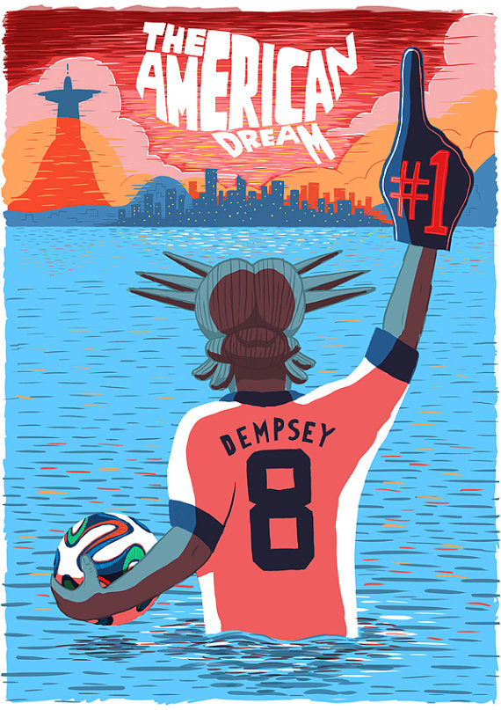

Read
- Andrei S. Markovits, “The Other American Exceptionalism: Why is there No Soccer in the United States?” International Journal of the History of Sport (1990) 230-259
- Tom Dunmore, “Truth, Crushed to Earth, Shall Rise Again: The Howard University Soccer Team’s Journey of Redemption,” XI Quarterly 1, 1 (2012): 43-59
- Javier Pescador, “Los Heroes Del Domingo: Soccer, Borders, and Social Spaces in Great Lakes Mexican Communities, 1940-1970,” in J. Iber and S. O. Regalado, eds., Mexican Americans and Sports, 73-87
- Matthew Struttner, Charles Parrish, John Nauright, “Making Soccer ‘Major League’ in the USA and Beyond: Major League Soccer’s First Decade” Sport History Review 45 (2013): 23-36
- *Dave Wangerin, Distant Corners: American Soccer’s History of Missed Opportunities and Lost Causes, 58-100

Recommended
- Andrei S. Markovits and Steven L. Hellerman, Offside: Soccer and American Exceptionalism in Sport
- Dave Wangerin, Soccer in a Football World
- Stefan Szymanski and Andrew Zimbalist, National Pastime: How Americans Play Baseball and the Rest of the World Plays Soccer
- Geoffrey Douglas, Game of their Lives: The Untold Story of the World Cup’s Biggest Upset
- Gavin Newsham, Once in a Lifetime: The Incredible Story of the New York Cosmos
- Nathan Abrams, “Inhibited but not ‘Crowded Out’ The Strange Fate of Soccer in the United States,” International Journal of the History of Sport 12, 3 (1995): 1-17
- Steven Apostolov, “Everywhere and Nowhere: the Forgotten Past and Clouded Future of American Professional Soccer from the Perspective of Massachusetts,” Soccer & Society 13, 4 (2012): 510–535
- Gabe Logan “The Rise of Early Chicago Soccer,” in Elliot Gorn, ed., Sports in Chicago, 19-42
- Gwendolyn Oxenham, Finding the Game

4/24: WAR MINUS THE SHOOTING? BARCELONA vs. REAL MADRID

Read
- Sid Lowe, Fear and Loathing in La Liga: Barcelona vs Real Madrid

Recommended
- Alejandro Quiroga, Football and National Identities in Spain
- Timothy J. Shaw, Soccer in Spain: Politics, Literature, and Film
- Ramón Llopis-Goig, Spanish Football and Social Change: Sociological Investigations
- Mariann Vaczi, “The Spanish Fury: A Political Geography of Soccer in Spain,” International Review for the Sociology of Sport 50, 2 (2015): 196-210
- Shmuel Nili (Shmulik), “The Rules of the Game—Nationalism, Globalisation and Football in Spain: Barça and Bilbao in a Comparative Perspective,” Global Society 23, 3 (2009): 245-268
- Jeremy MacClancy, “Nationalism at Play: The Basques of Vizcaya and Athletic Club de Bilbao,” in J. MacClancy, ed., Sport, Ethnicity, and Identity, 181-199
- Phil Ball, Morbo: The Story of Spanish Football
- Simon Kuper, Football Against the Enemy
- Bill Murray, The Old Firm: Sectarianism, Sport and Society in Scotland
- Josph M. Bradley, “Celtic Football Club, Irish Ethnicity, and Scottish Society,” New Hibernia Review 12, 1 (2008): 96-110

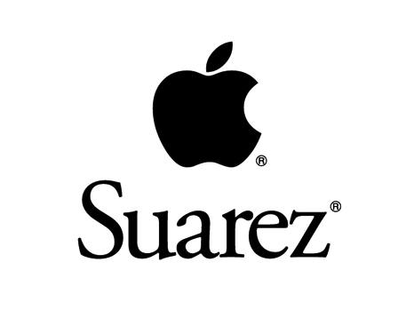

Special thanks to Dan Leydon for the football art!

danleydon.tumblr.com

